**ADVANCE DATABASE MANAGEMENT SYSTEM PROJECT REPORT**

**Rajashekar Reddy Patlori, Lokesh Anjaneya Pothana, Rajashekhar Reddy Chinthalapalli, Kandapu Ajita, and Yogeshwar Reddy Kandati**

**Project Aim**

This project aims to add Oscar awards data and develop a system that enhances the existing movie database (SQL DB).

**Project Requirement**

The focus of the project is to create two Oscar award tables one is for actors and the other is for writers & directors to specify the artists who are nominees and winners of Oscar Awards for the movies which are in the movie table.

**Database Design**

Partitioned data as actors, writers, and directors referring to the data set gathered from the Kaggle website. Developed two tables in SQL111 that are the “Actors Oscar Award” and “Job Oscar Award”. The actors’ Oscar Award table specifies the data of artists who are nominees and winners of the Oscar Awards and their role names. The Job Oscar Award table provides information on writers and directors who are the nominees and winners of the Oscar Awards.

In the process of building the Oscar awards tables sorted all the movies, and person names from the data set which are unique with the respective tables of movies, movie_actors, and movie_jobs. And created two different excel sheets for actors and jobs that are nominated and won awards and then exported to the database.

These two tables contain the details of the movie name, release year, ceremony year, person name, category, Role Name, Job Code, and award status. We have built the tables with reference to the tables like movies, movie_actors, movies jobs, and persons using columns like movie_guid, person_name, movie_title, and person_guid.

**Screenshots**

ACTOR_OSCAR_AWARDS table details

ACTOR_OSCAR_AWARDS model

ACTOR_OSCAR_AWARDS table constraints

ACTOR_OSCAR_AWARDS Data Sample

JOB_OSCAR_AWARDS table details

JOB_OSCAR_AWARDS model

JOB_OSCAR_AWARDS table constraints

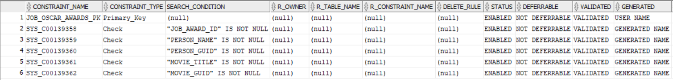

JOB_OSCAR_AWARDS Data Sample

**Entity Relationship Diagram (Excluding all other tables)**

**Query writing**

**Query 1**

Display the list of actors who have been nominated and won Oscar awards for the movie “12 Years a Slave” movie.

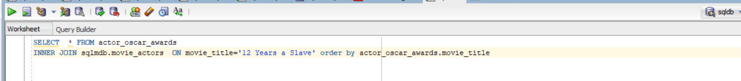

**Query 2**

Displays the list of all the actors their award status and the movie they have acted in.

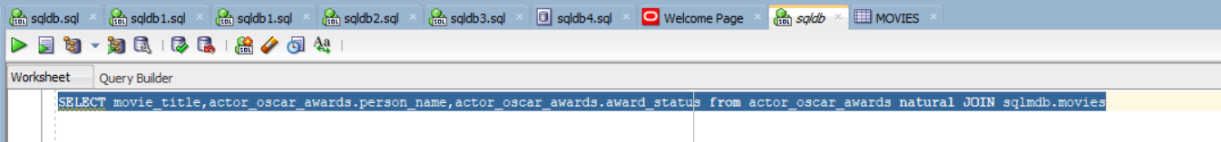

**Query 3**

Displays the list of all the actors who have won the Oscar wards

**Query 4**

Displays the list of all the actors, writers, and directors who have been Nominated and won the Oscar wards.

**Query 5**

Displays the list of all the writers, and directors who have been Nominated for the Oscar awards.



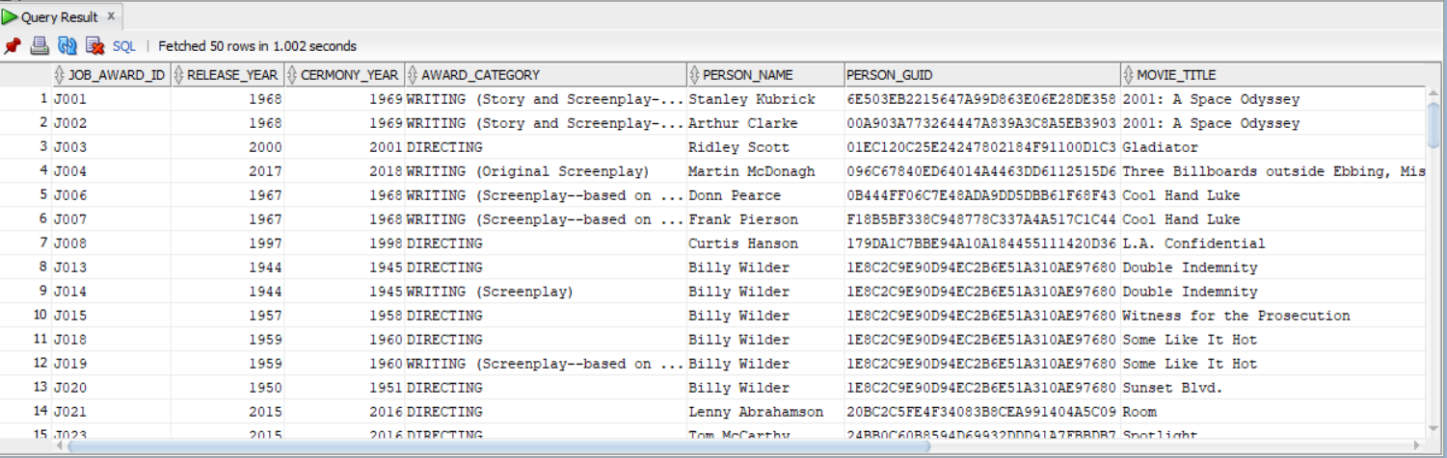

**Performance Tuning**

SQL tuning is the process of boosting up SQL queries to accelerate your server’s performance. The general purpose is to bring down the time it takes a user to receive a result after issuing a query and reduce the number of resources used to process a query.

**Index**

The index is a table that gives faster query results and data retrieval from the database. Index tables use indexing, an approach that makes data structures speed up a database query's searching time. Indexing makes database performance better and consumes lesser memory in the main memory.

Before indexing, we can notice that the scan is full-time, and costs are high

After creating the index and implementing the same select statement the cost and time has been reduced.

**Optimizer modes**

ALL_ROWS is the default optimizer Getting all rows faster is good for untuned, high-volume batch systems.

FIRST_ROWS Gets the first row faster this is good for untuned systems that process lots of single transactions.

**Parallel Execution**

Parallel execution divides the task of implementing an SQL statement into multiple small units, each of which is executed by a separate process. Parallel execution is designed to effectively use multiple CPUs and disks to answer queries quickly. When multiple users use parallel execution at the same time, it is easy to quickly exhaust available CPU, memory, and disk resources.

**Degree Of Parallelism**

The number of parallel execution servers associated with a single operation is known as the degree of parallelism.

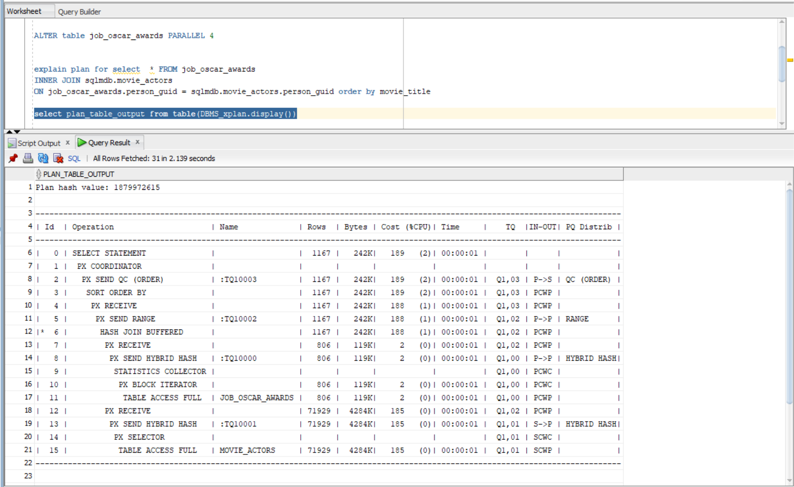

**Data Visualization**

Visualization of the data that was inserted is also an important aspect when it comes to understanding the data more efficiently. In this project visualizations are done for the Award category, Number of actors, Award winners, Number of awards for movies, and top 30 most award winners in the ACTOR_OSCAR_AWARDS table.

In the JOB_OSCAR_AWARDS table visualizations are done for the Award category, Number of actors, Award category, Award winners, Number of awards for top 30 movies, and top 30 most award winners and their job.

**Conclusion**

Created two tables “Actors Oscar Award” and “Job Oscar Award” with reference to the movies and persons which are in the existing movies, movie_actors and movie_jobs tables which will display the data of the actors, writers, and directors who won and nominated for Oscar awards. Did a couple of experiments on the project for performance tuning with indexing, optimizer mode, and Parallel Execution. Used data visualization to understand better and get more insights on data. Thus achieved the goal to include the awards table in the database efficiently.

**References**

<https://www.w3schools.com/sql>

<https://lucid.app/>